Questions and Exercises to work out and turn in:
Grading Guidelines (See Appendix):
In general, a right answer will get full credit when:

- It is right (worth 25%)
- It is right AND neatly presented making it easy and pleasant to read. (worth an extra 15%)
- There is an obvious and clear link between 1) the information provided in the exercise and in class and 2) the final answer. A clear link is built by properly writing, justifying, and documenting an answer (worth an extra 60%).
- Calculation mistakes will be minimally penalized (2 to 5% of full credit) while errors on units will be more heavily penalized.

Late Submission : as specified in the syllabus. Day counting starts one minute after the deadline.
Check Your Submission: after submitting, download your submission to check whether it is the right version and it is complete. A wrong version will get at least a 25 points penalty that cannot be claimed back by the Leniency Policy for Borderline Incidents. So, check your submissions.

You are welcome/encouraged to discuss exercises with other groups or the instructor. But, ultimately, personal writing is expected.

- USE THIS EDITABLE FILE AS THE STARTING DOCUMENT YOU WILL TURN IN. KEEP IN THE QUESTIONS AND INSERT YOUR ANSWERS RIGHT AFTER THE QUESTIONS/PROMPTS. DO NOT DELETE ANYTHING.
- IF USING HAND WRITING (STRONGLY DISCOURAGED), REWRITE THE QUESTIONS.
- FAILING TO FOLLOW TURN IN DIRECTIONS /GUIDELINES WILL COST A 30% PENALTY.

Objectives of this assignment:
- Initiate you to work on a Unix like system
- Introduction to basic Unix commands.

What you need to do: (Start early: many problems could arise.)
- One submission per team. You must complete all tasks on an Engineering Unix Tux machine, otherwise a 0 will be assigned.
- Execute basic Unix commands on Engineering Tux machines.
- Always document your work by taking/inserting screenshots. To save space, clip out the screenshots to contain only relevant information.
- Insert answers as indicated (right after the question/directions)

Exercise 1 (100 points) (Well written short answers are acceptable for this assignment)
The objective of this exercise is to get familiar with basic commands to create a few directories for this course on the H (Home drive) using a Tux machine.
Task 1: (10 points)
Log in remotely on the Engineering Tux machines
Help to log on: (See attached Video))
Method 1: To log in remotely, you must use an ssh client such as SecureCRT (Windows). The software SecureCRT is available on AU Install. It runs only on Windows.

Method 2: On Windows 10, you may use from the command prompt the following command (if ssh is available): ssh username@gate.eng.auburn.edu
where username is your Auburn University username.

Method 3: On Mac or any Unix machine (Ubuntu...), use the same command
ssh username@gate.eng.auburn.edu on a terminal.

After you successfully succeed to log onto a Tux machine, take and insert a screenshot of the window of SecureCRT or your terminal (on Mac, Windows or any other command terminal).
In order to save space, for this assignment and all FUTURE ones, clip out the screenshots to contain only the relevant information. When applicable, ALL screenshots must show the date, the Tux machine name you are using for the exercise and the Auburn username. A 25 points penalty will be applied if any information (date, tux machine name, or username) is missing. Make sure that the screenshots are as easily readable as the template screenshot below:
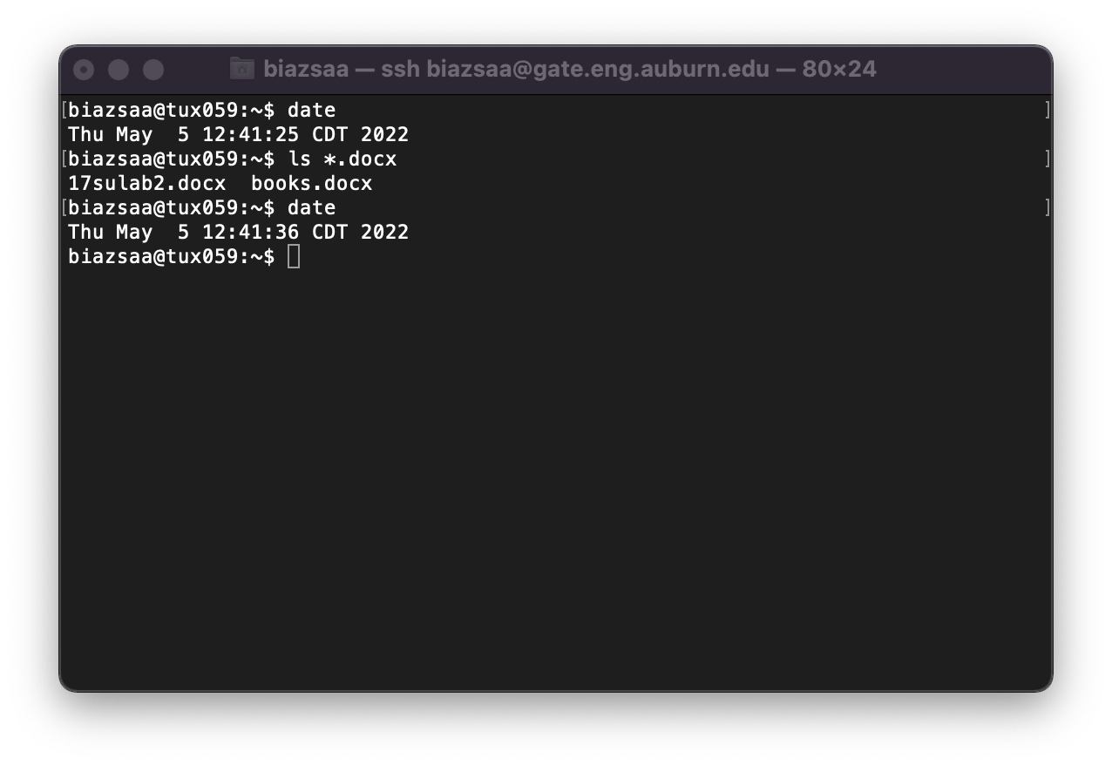
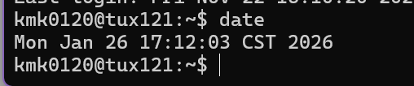
This screenshot is for Task 1, signing into the engineering tux machine. It shows the date is Monday, January 26th at 17:12:03 CST, year 2026. It also shows the username is kmk0120, and the tux machine I am on is tux121.
Task 2: (Pay attention to the questions in blue. Answer those questions)
After you log onto a Tux machine, you must create a parent directory named nnnn where nnnn is this course's number. If this course's number is 3270, then you must name the parent directory 3270. You can think of "directory" as a folder (for Windows or Mac OS terminologies). We call the Directory nnnn a parent directory because this directory will contain all directories and files that you will create for this course. You must create inside the parent directory nnnn five directories called lab1, lab2, lab3, lab4, and lab6. To help you complete this task, we will guide you through the first steps:
1) As soon as you log in, type on the command line: ls
(5 points) what does the command ls do? You could use the command man ls
Insert a screenshot and answer here ......
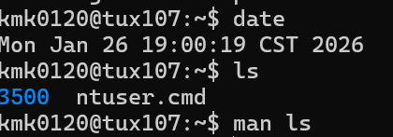
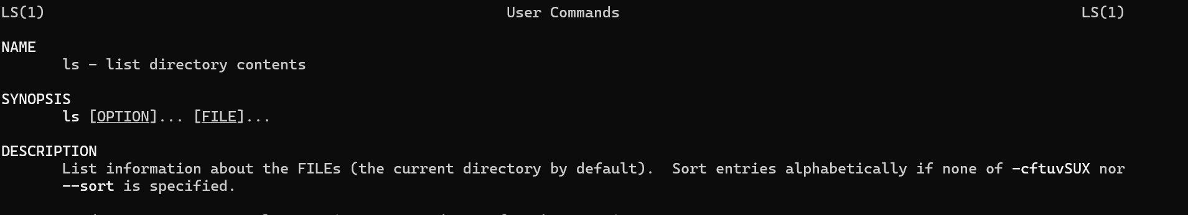
The command “ls” is used to display the contents of the current working directory and sort them alphabetically.

(4 points) what does the command man do? You could use the command man man
Insert a screenshot and answer here ......
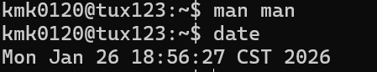
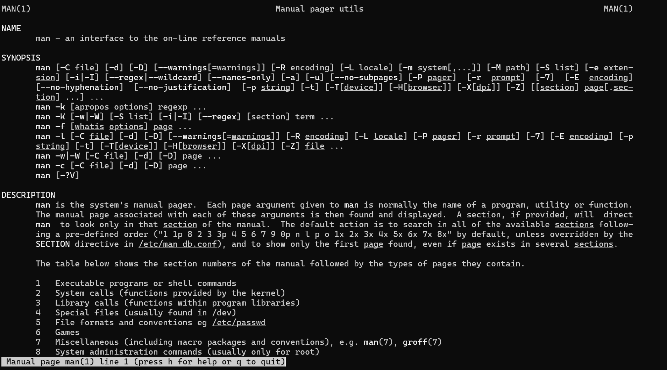
The command “man” displays the system's manual page for the argument given, which is typically a utility, function, or program. These manual pages help explain what the argument may do or how it may be used.
2) (9 points) type the command ls -al
What is the difference between ls and ls -al?
Answer here ......
The command “ls” displays the contents of a directory, but in a default format, and does not show hidden files that are indicated by a period. Using the command “ls -al” lists the files in a directory, but the -a command in it allows hidden files to be displayed by not ignoring files starting in “.”, and the “-l” command lets it be listed in long list format that displays more information about the files in columns of information with a row for each piece of content. The command “ls -al” is how you use both “-a” and “-l”. So “ls” gives a default list of the contents in a directory, excluding hidden files, while “ls -al” gives the long list form that has more information in columns, a row for each piece of content, and shows hidden files.

3) (9 points) type the command mkdir nnnn (where nnnn is this course's number)
The above command mkdir nnnn will create a directory named nnnn. Type the command ls -al to check that this directory named nnnn was created inside the home directory: the home directory is the default directory you are in when you log on a Tux machine.
Take a screenshot showing the list of files or directories inside the current directory (home).
Insert the screenshot here...... (clip out the screenshot to show only the relevant information)
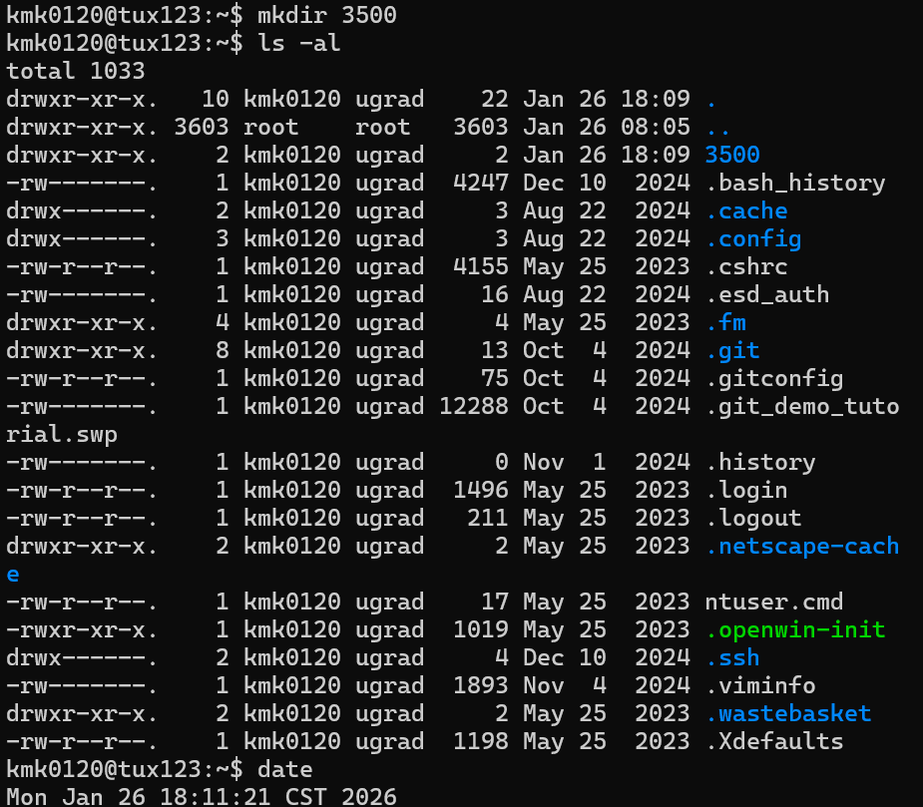
4) (9 points) type the command cd nnnn (where nnnn is this course's number) (this command will "move" you into the directory nnnn
Take a screenshot showing the prompt.
Insert the screenshot here...... (clip out the screenshot to show only the relevant information)
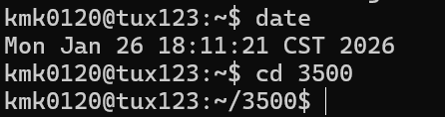

5) (9 points) type the command ls -al
Take a screenshot showing the list of files or directories inside nnnn.
Insert the screenshot here ...... (clip out the screenshot to show only the relevant information)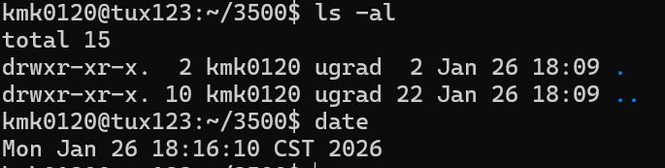
You should see two files (or directories?) named '.' and '..'
Search on Google what '.' and '..' are.
What are those "files" (or directories?) '.' and '..'?
Answer here....
The ‘.’ And ‘..’ are automatically created reference files or directories made when creating a directory. They act as shortcuts. The ‘.’ References the current directory, which is helpful when using a relative path to describe a location. The ‘..’ references the parent directory and allows you to move up the hierarchy of directories.

6) (9 points) Create 5 directories named lab1, lab2, lab3, lab4, and lab6 inside the directory nnnn. List below the commands you must type to create 5 directories named lab1, lab2, lab3, lab4, and lab6.
Insert the screenshot here and answer here (list here the commands) .... (clip out the screenshot ….)
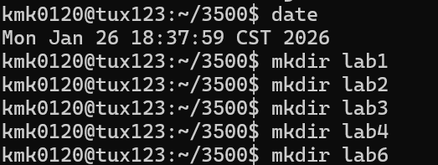
For my directory nnnn I am using 3500. Since I am already inside the desired parent directory, 3500, due to using the command ‘cd 3500’ in step 4, I can now use the command ‘mkdir’ to create directories inside 3500. So the commands I must use to create the 5 directories named lab1, lab2, lab3, lab4, and lab6 are:
- mkdir lab1
- mkdir lab2
- mkdir lab3
- mkdir lab4
- mkdir lab6

7) (9 points) type the command ls -al
Take a screenshot showing the list of files or directories inside Directory nnnn.
Insert the screenshot here ...... (clip out the screenshot ...... ........... ...)
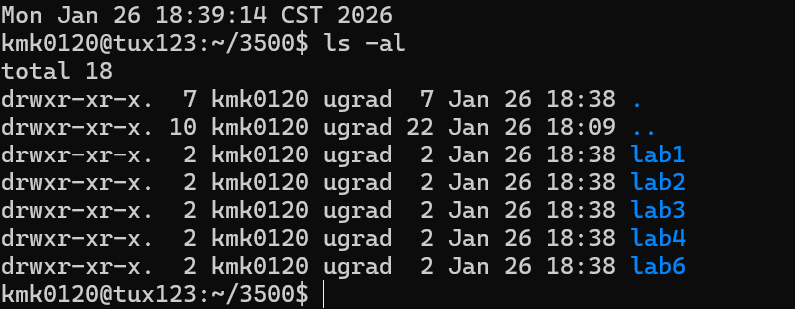
8) (9 points) What command should you type to "move" inside the directory lab3
Provide here the command needed to "move" inside the directory lab3
Answer here....
Since we are already in the parent directory 3500 due to step 4, we just need to use ‘cd lab3’ to move into the directory lab3.

9) (9 points) type the command ls -al (while inside the directory lab3)
Take a screenshot showing the command line "ls -al" and the content of the directory lab3.
Insert the screenshot here...... (clip ......)
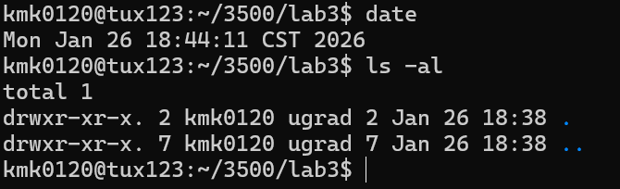

10) (9 points) which command should you type to "move up" to the parent directory of lab3?
Answer here. Tell us how you found the command.
The command to move up into the parent directory of lab3 is “cd ..” I found the command by using the logic in this lab exercise. Step 4 and Step 8 showed me that cd is used to move into directories. In addition, in Step 5, I answered that ‘.’ and ‘..’ are used to reference the current file (‘.’) and the parent file (‘..’). I also learned in Step 5 that those reference files are automatically created when creating directories, so I experimented by typing ‘cd ..’ into my terminal and saw that “~/3500/lab3$” (which showed I was in the directory lab3 whose parent directory was 3500) changed to “~/3500$”. This told me I had moved up into the parent directory and that the command worked.

Start early: many problems could arise.
If you have problems to log in remotely to Tux machines, ask on Piazza for help.

Reminder: In order to save space, for this assignment and ALL FUTURE ones, clip out the screenshots to contain only the relevant information. When applicable, ALL screenshots must show the date, the Tux machine you are using for the exercise and the Auburn username. Throughout the semester, a 25 penalty will be applied if a screenshot is missing any of the required information: date, username, or Tux machine name. Make sure that the screenshots are easily readable. Screenshots must be as readable as the template screenshot below:


What you need to turn in:
- Electronic copy of this file (including your answers) (standalone). Submit the file as a Microsoft Word or PDF file.

- Recall that answers must be well written, documented, justified, and presented to get full credit.

- How this assignment will be graded:
- A right answer will get full credit when:
- It is right (worth 25%)
- It is right AND neatly presented making it easy and pleasant to read. (worth 15%)
- There is an obvious and clear link between 1) the information provided in the exercise and in class and 2) the final answer. A clear link is built by properly writing, justifying, and documenting an answer (worth 60%).
- Calculation mistakes will be minimally penalized (2 to 5% of full credit) while errors on units will be more heavily penalized.

- You are welcome/encouraged to discuss exercises with other students or the instructor. But, ultimately, personal writing is expected.

Appendix: Grading: What is an OBVIOUS and CLEAR LINK?
Here is an example to explain what an obvious and clear link is and how we grade your work.
Consider the following problem:
"(100 points) John travels from Auburn to Atlanta in his car at a speed of 50 mph. Leaving at 8am, at what time will John reach Atlanta".
Here are the answers of three students and their scores:
Student 1 answers: "10am". Student 1 will get 25 points.
Student 2 answers : "John will reach Atlanta at 10am". Student 2 will get 25+15 = 40 points
Student 3 answers: "The time t to travel a distance d at speed v is equal to d/v = d/50mph. The problem does not provide the distance d from Auburn to Atlanta. Based on Google, the distance from Auburn to Atlanta is approximately 100 miles (document is here). Therefore, the time t = 100 miles/50mph = 2 hours. Since John left at 8am, he will then reach Atlanta at 8am + 2 hours = 10 am".
Student 3 will get 25 + 15 + 60 = 100 points
Do you see the direct link going from the data provided in the question to the final answer, using general knowledge/formula and documents?.... Can you now solve the following problem and get 100 points?
"(100 points) Alice travels from Auburn to Atlanta in her car at a speed of 50 mph. Leaving at 8am, at what time will Alice reach Atlanta assuming that she had a flat tire that delayed her 30 minutes".

Screenshot: Required Information
In order to save space, for this assignment and all FUTURE ones, clip out the screenshots to contain only the relevant information. When applicable, ALL screenshots must show the date, the machine you are using for the exercise and the username of one of the team mates. Make sure that the screenshots are easily readable. Below is template screenshot:


See on the appendix what an obvious and clear link is.

